Muhammad Raza Mesum Rizvi (Student1103523), Mehwish Tariq (Student 1114548), Muhammad Sameer (Student1100106), Muhammad Affan Khan (Student1088697)

EVENT MANEMENT SYSTEM

[Document subtitle]

**Faculty** = Miss Aatika Liaquat,

**Batch code** = 1804B1

**Curriculum**= 6673,

**Semester**= DISM,



APTECH | North NAZIMABAD

http://www.aptechnn.com

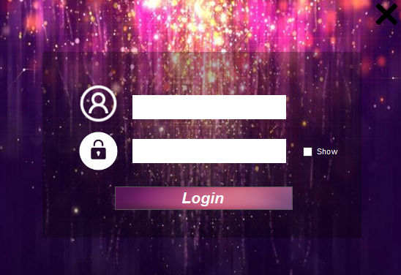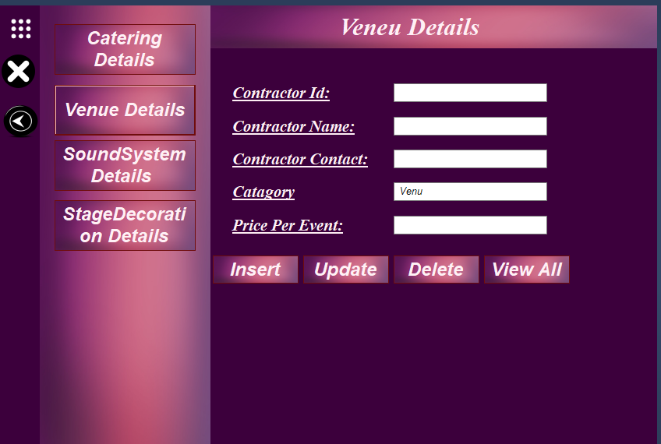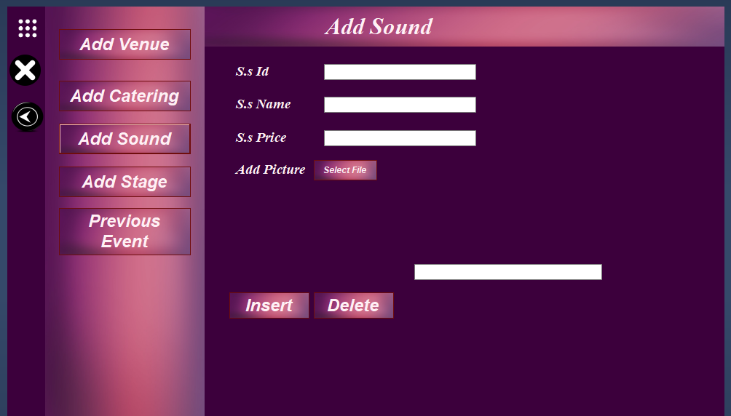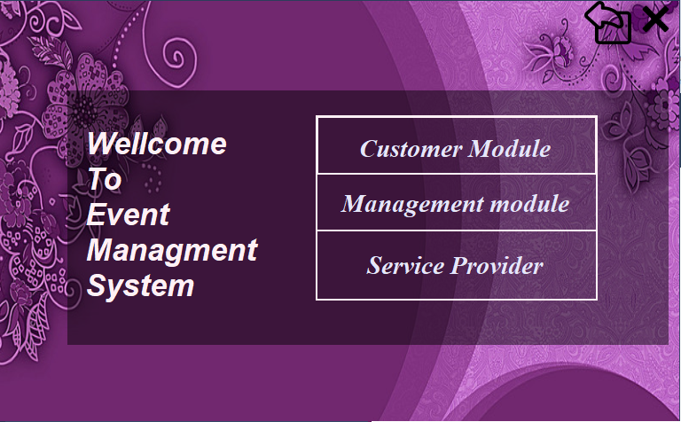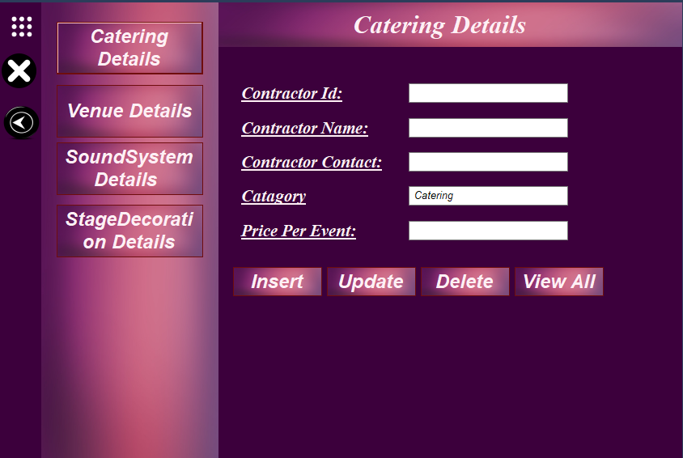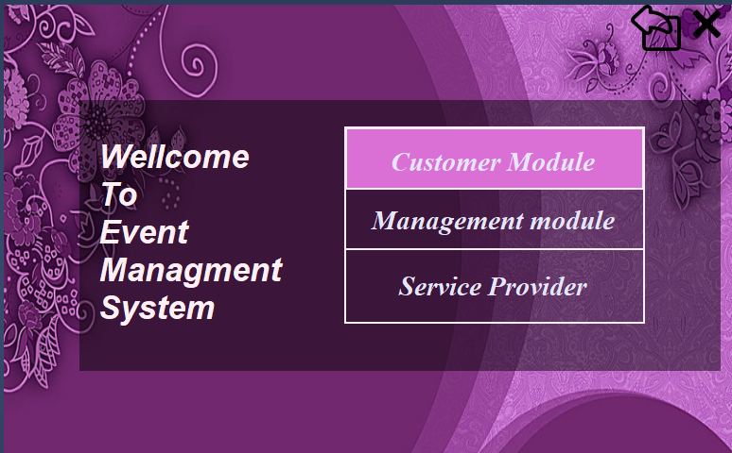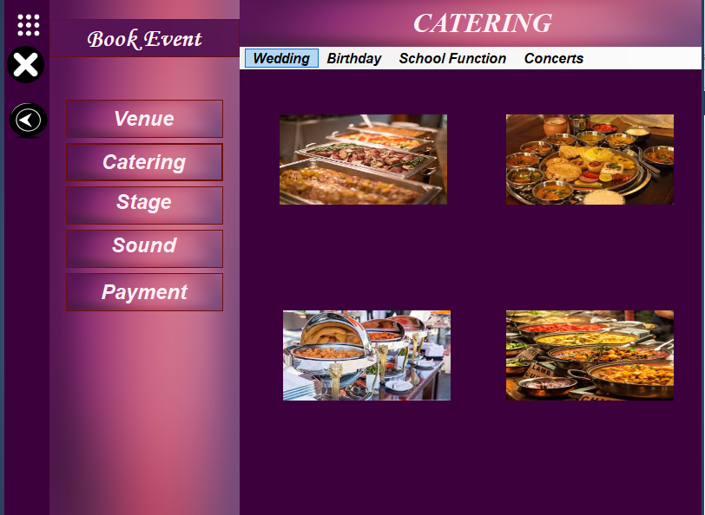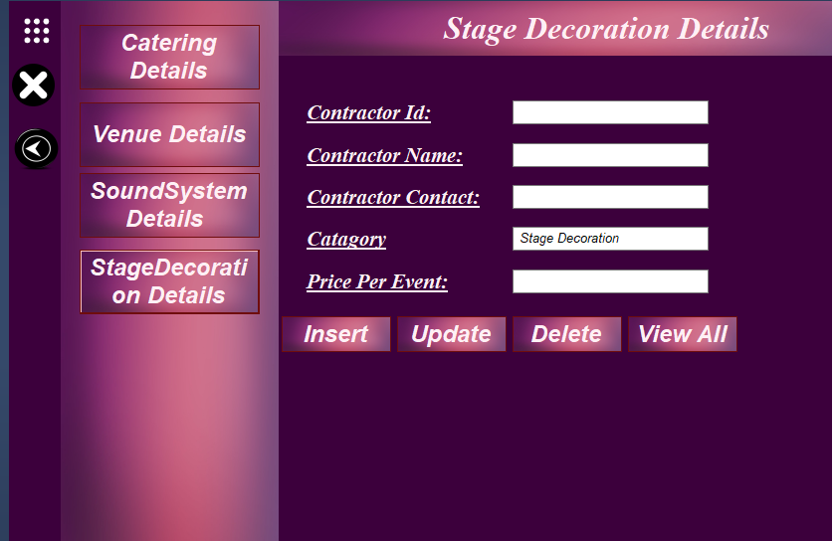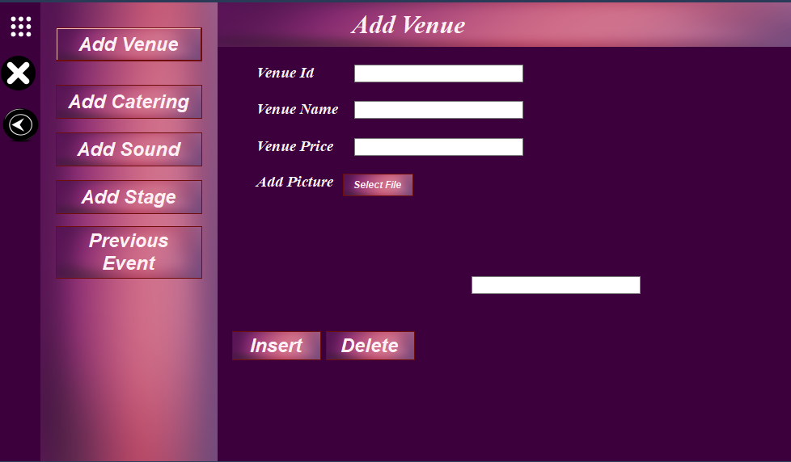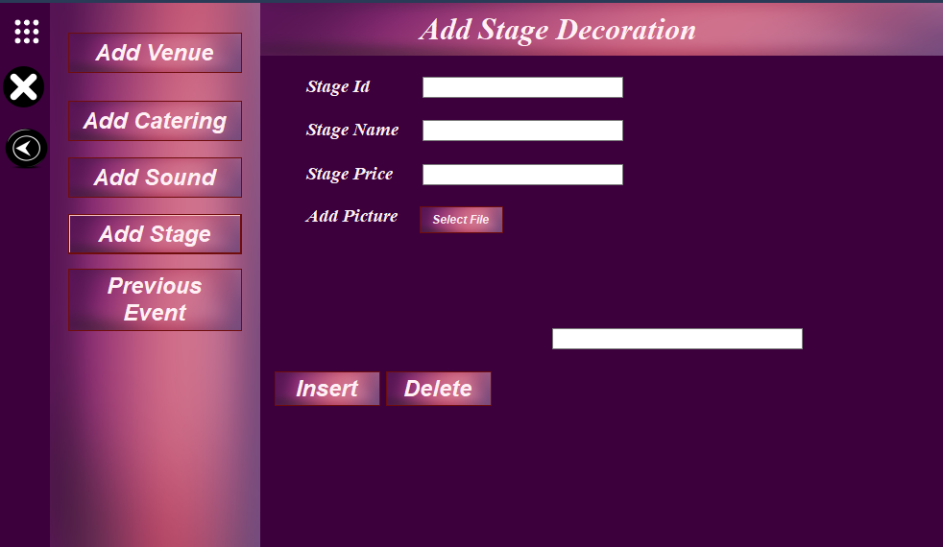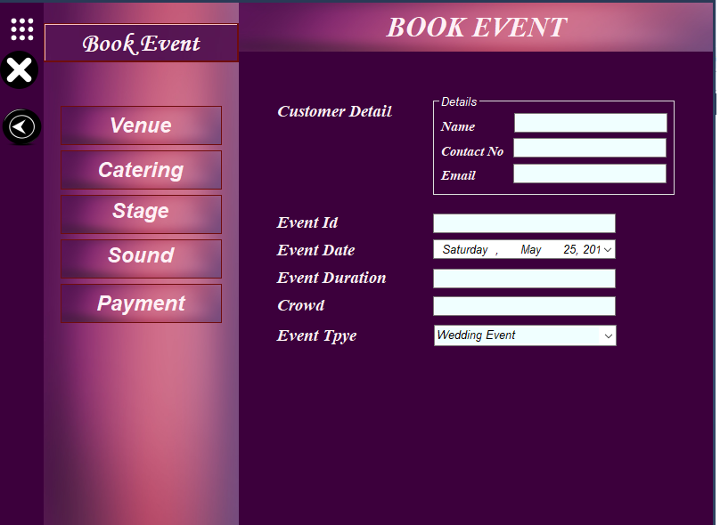

**Thank you for**

**reading**